INVITATION FOR QUOTATION
FOR SUPPLY OF FURNITURE

Quotation ID.: MANT/CO/SRIJAN/2026-27/07 Dated: 19.09.2026

Manbhum Ananda Ashram Nityananda Trust (MANT) invites sealed quotations / digital quotations from reputed and authorized suppliers for the supply of furniture at Balurghat, Dakshin Dinajpur District, under Project SRIJAN, supported by HDFC Bank Parivartan.

- Item Details
Sl. No. | Item Description | Quantity Required
1 | Almirah (plywood) | 21 nos
2 | Tarpaulin (Length 18 ft and Width 12 ft) | 21 nos

- Technical Specifications and Requirements
Almirah
- Made of hard plywood with wooden-finish pasting (sunboard).
- Door: Two-door system.
- Dimensions: 30 inches (L) × 16 inches (W) × 36 inches (H).
Tarpaulin: Minimum 240 GSM, size 18 ft × 12 ft.Eligibility Criteria
- The bidder shall possess valid GST, PAN, and required documents, wherever applicable.
- Submission of Quotation
  - The quotation must be submitted in a sealed envelope and dropped into the tender box at the SRIJAN Project office, BT Park, Power House, Balurghat- 733103
  - For Digital copy, email us at: mant.kolkata@gmail.com, CC to: acctsrijan@gmail.com; sourav@mant.org.in; and anirban@cphr-mant.in; clearly mentioning “FOR THE __________ (specific item name) <space> Specifications – Quotation ID:, Dated:.”
  - Kindly note that mentioning and marking copies to all given email IDs during quotation submission is mandatory; otherwise, the quotation may be treated as invalid.
- Important Dates
- Last date for submission: 22th September, 2026
- Opening of quotations: 23th September, 2026
- Validity: All quoted rates should be valid for at least 60 days from the date of opening of the quotation.
- The purchase order will be issued within 7 days of the opening of the quotation, unless delayed by unforeseen circumstances.
- Delivery Timeline: Within 15 days from the date of issue of the Purchase order
- Contact Information
For any clarification, please e-mail: mant.kolkata@gmail.com / acctsrijan@gmail.com / anirban@cphr-mant.in / sourav@mant.org.in , Phone: +91-7044974566/ 6291565113.

- Terms & Conditions
  - MANT reserves the right to accept or reject any or all quotations without assigning any reason.
  - Bidders may quote for one or more categories. Evaluation may be undertaken item-wise.
  - Technical responsiveness shall be assessed before commercial comparison. Procurement shall not necessarily be awarded to the lowest-priced quotation.
  - Damaged, expired, or improperly packed items shall be replaced by the supplier at no additional cost.
  - MANT reserves the right to increase or decrease the quantity of items to be procured.
  - Payment shall be made through RTGS/NEFT Bank Transfer only.
  - The quotation must bear the authorized signature and official seal of the supplier.
  - If the vendor is not previously registered with MANT, the prescribed Vendor Authentication/Registration Form with required documents must be submitted. MANT reserves the right to cancel the PO/order, even after issuance, and/or temporarily or permanently block the vendor in case of non-compliance or false information.

S/d
Dr. Nirmalya Mukherjee
Chief Executive
Manbhum Ananda Ashram Nityananda Trust (MANT)

Reference Diagram of Almirah
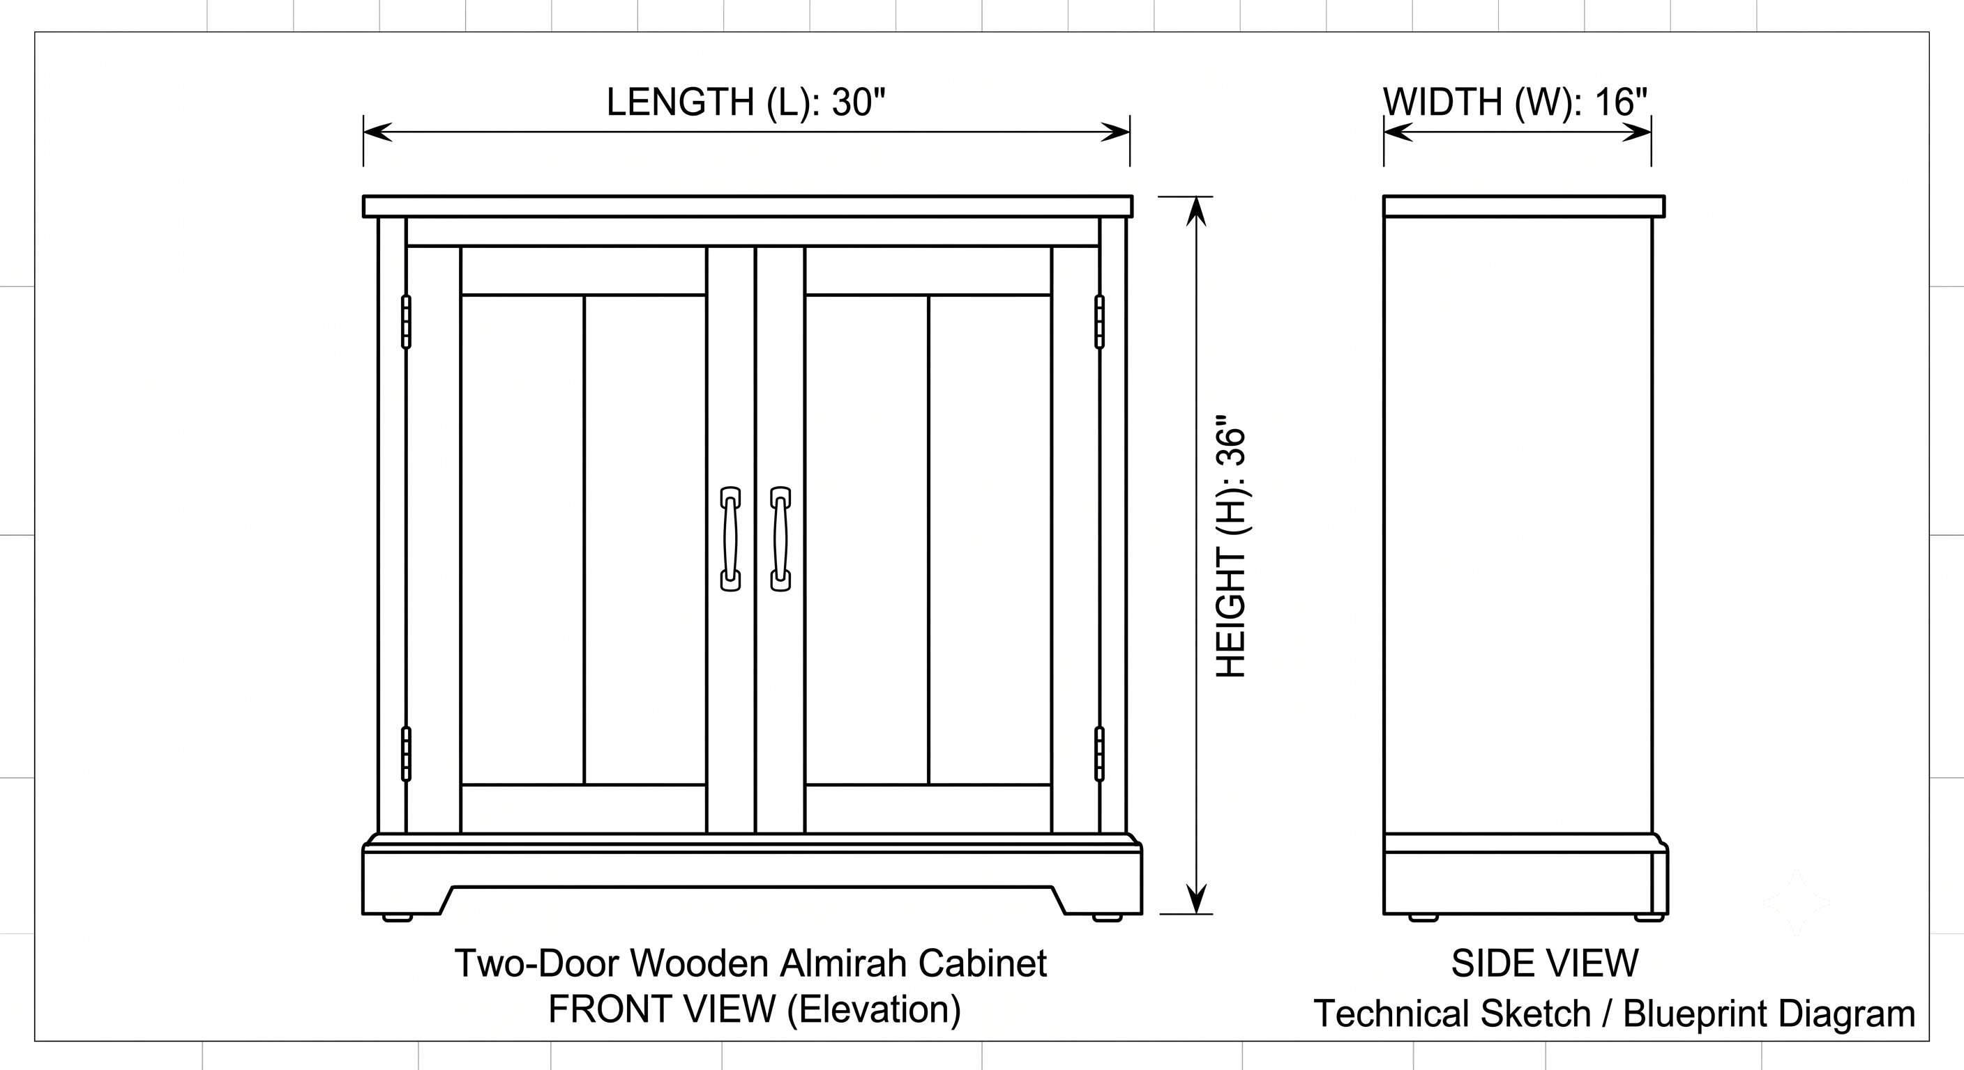

NB: This Diagram should be used as a reference; the original model doesn't need to be identical to the diagram

