INVITATION FOR QUOTATION
FOR THE AREATORS (2 HP PUMP) FOR NURSERY POND

Quotation ID.: MANT/CO/SRIJAN/2025-26/16 Dated: 17.02.2026

Manbhum Ananda Ashram Nityananda Trust (MANT) invites sealed quotations from reputed and authorized contractors FOR THE AREATORS (2 HP PUMP) FOR NURSERY POND
At Dakshin Dinajpur, under the SRIJAN Project, supported by HDFC Bank Parivartan.

- Item Details
Sl No | Item Descriptions | Location | Unit
1 | Areator (Worm model) with 4 paddles, including 2 HP pumps | To be supplied at different locations  of Dakshin Dinajpur district | 4

- Technical Specifications and Requirements

  - Pond Size up to 0.5 acres and Depth up to 10 ft.
  - Pump should be branded by a company like CRI, Unnyati will be the preference.
  - Warranty period of pump and motor should be 2 years, and on the other materials should be 1 year
  - GST: As applicable under Government norms, and must be clearly mentioned in the quotation (if applicable).

- Eligibility Criteria
- Experience in pond nursery management

- Submission of Quotation
- The quotation must be submitted in a sealed envelope/Digital copy (by mail: sourav@mant.org.in or acctsrijan@gmail.com clearly mentioning “FOR FOR THE AREATORS (2 HP PUMP) FOR NURSERY POND <space> BLOCK NAME – Quotation ID:, Dated:.”
- Important Dates
- Last date for submission: 23rd February, 2026
- Opening of quotations: 25 ^{th} February, 2026
- Validity: All quoted rates should be valid for at least 90 days from the date of opening of the quotation.
- Purchase order will be issued within 7 days of opening of quotations, unless delayed by unforeseen circumstances
- Delivery Timeline: Within 15 days from the date of issue of the Purchase order

- Contact Information
For any clarification, please e-mail: mant.kolkata@gmail.com / acctsrijan@gmail.com / sourav@mant.org.in , Phone: +91-7044974566/ 6291565113

- Terms & Conditions
- MANT reserves the right to accept or reject any or all quotations without assigning any reason.
- Incomplete or conditional quotations shall be summarily rejected.
- MANT should not pay more than 40% as an advance.
- All statutory and government permissions related to excavation shall be the sole responsibility of the contractor.
- Quotations must be submitted on a consolidated, site-verified contract basis; hourly or machine-wise rates will not be accepted.
- Mode of payment: Online Bank Transfer through RTGS / NEFT
- The number of units shown is tentative and might vary as per actual field requirement or requisition
- A schematic outline drawing is given below for illustrative purposes only
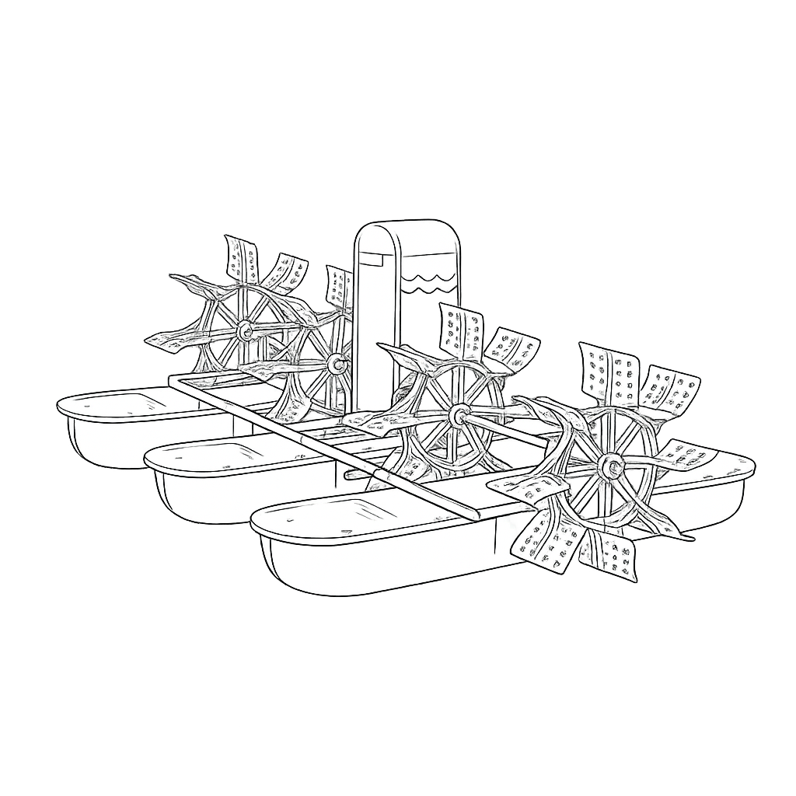
S/d
Dr. Nirmalya Mukherjee
Chief Executive
Manbhum Ananda Ashram Nityananda Trust (MANT)

